Information pack for the post of
Advanced Clinical Practitioner (ACP)
Division of
Urgent and Emergency Care

November 2023

Hello and welcome to our Trust! I am delighted that you are considering our organisation as a place to work.
This is a really exciting time for our patients and staff as we work with our local health system partners across Cambridgeshire, Peterborough and South Lincolnshire to deliver some key development projects that will shape the care we provide for future generations within the 900,000-strong catchment we serve. As well as building a new hospital at Hinchingbrooke and redeveloping our sites at Peterborough and Stamford to better meet the needs of patients, we are investing in a Trust-wide electronic patient record system and harnessing digital technology within our diagnostic services to enhance the quality and speed of diagnosis and treatment.
It’s a great time to be joining TeamNWAngliaFT where we truly value the health and wellbeing of our staff and encourage our leadership team to empower their teams to be the best they can be, to help them develop in their careers and, at the same time, ensure our patients can experience good quality care by people who are dedicated to serving their health needs.
If you are looking to develop your career in an environment that’s primed for organisational change, where you can actively contribute to the quality improvements we are making for our patients and staff, then look no further for your next role.
Hannah Coffey
Chief Executive Officer

Job Description
JOB TITLE | Advanced Clinical Practitioner (ACP)
GRADE | Band 8a
DEPARTMENT | Urgent and Emergency Care (UEC) Division
BASE | Peterborough City Hospital
RESPONSIBLE TO | Consultant Clinical Supervisor
ACCOUNTABLE TO | Clinical Lead

Job Summary

The post holder will practice independently within the Consultant led ACU and be a role model of the four pillars of Advanced Practice. This clinically focussed role will encompass the post holder providing exemplary patient-centred and sound evidenced based care to patients with undifferentiated and undiagnosed problems. The post holder will provide clinical coordination of a multi-disciplinary team across different areas of the department, clinical floor management responsibilities, education and mentorship, senior clinician support, second opinion advice and support to junior clinicians during a span of duty. The post holder will demonstrate excellent interpersonal and communication skills and clinical attributes, enabling them to provide expert clinical and professional support to other clinicians and staff within their area of work of the Urgent and Emergency Care (UEC) Division.

Main Duties and Responsibilities
Working towards delivery of advanced standards of practice within the following key areas of practice and in line with the National Standards.
• Clinical – demonstrate critical understanding of their broadened level of responsibility and autonomy and their own limits of competence and Scope of Practice.
• Management and Leadership – able to role model effective leadership behaviours, show resilience and manage effective governance strategies, which support the agenda for change within the Trust.
• Education and Training – able to identify, support and develop learning interventions for both self and team members.
• Audit and Research – to look at areas for quality improvements to care, use audit processes and both formal and informal research methods to improve service delivery.
• Additional areas:
• Financial – ensure considered cost appraisal when requesting or referring for investigations, ordering stores or equipment, booking training/courses or when involved in service development and recruitment activities.
• Resource Management – ensures appropriate use and distribution or clinical and non-clinical resources. Support the development of junior staff across a multidisciplinary team.
• Health and Safety – plays their part in maintaining a safe working environment, undertake mandatory training and actioning/reporting any concerns.
• Risk Management – ensure dynamic risk assessments a carried out and if required report, mitigate, minimise risk to staff and service users.
• Patient contact – in line with the Trust values and Standards of Care of professional body.
• Prescribing responsibility – must ensure Prescribing within the Professional, legal and clinical boundaries whilst ensuring adherence to the Trusts Non-Medical Prescribing policy.
• Scope of Practice – must maintain a professional registration with one of the recognised professions for role and ensure they are working within their professional and Trust guidelines and Standards.

Job Planning for Advanced Clinical Practitioner role:
The post holder will be required to work across these four pillars of practice, with a view to spending their time as indicated below. This will be governed by the use of Job Planning processes and will be the responsibility of the post holder to record accurately planned and actual time completed on each area of excellence.
Contracted Working Hours split:
• Approximately 10% of contracted hours per month will be assigned to undertake Clinical Governance items, i.e., RCA’s, incident closing, complaint responses and clinical audits.
• Approximately around 4% of contracted hours per month will be assigned to undertake and work with research projects within the speciality (if available/suitable)
The remainder of contracted time is for clinical capabilities/skills and assessments by meeting with clinical supervisors.
Specific Clinical competencies –This represents competencies which cover all the four pillars, detailed in Appendix A.
Core Competencies
1. Functions at an advanced level within healthcare organisation and management systems in line with their scope of practice and sphere of influence.
2. Able to deal with complex ethical and legal issues relating to patient care.
3. Selects and uses advanced communication skills to articulate and share their decision making, while maintaining appropriate situational awareness, displaying professional behaviour and exercising professional judgement.
4. Initiates, leads and delivers effective quality improvements in patient care, focused on maintaining patient safety.
5. Able to critically appraise and undertake research, including managing data appropriately.
6. Developing within the context of advanced level practice as a learner, teacher and supervisor.
Generic Clinical Competencies
1. Undertakes an advanced clinical assessment in the face of uncertainty and utilises critical thinking to inform diagnosis and decision making.
2. Leads acute intervention for patients, recognising the acutely deteriorating patient and delivering resuscitation.
3. Manages the assessment, diagnosis and plans future management of patients in an outpatient clinic, ambulatory, or community setting, including the management of long-term conditions, in the context of complexity and uncertainty.
4. Manages problems in patients in special cases and other specialities.
5. Manages a multi-professional team, including the planning and management of discharge planning in complex, dynamic situations.
6. Manages end-of-life care and applies palliative care skills in the context of complexity and uncertainty.

Speciality Clinical – Acute Medicine Services
1. Actively engages in acute medical service development, deliver and evaluation, including as a leader and role model.
2. Develops, supervises and delivers alternative patient pathways, including same-day emergency care (SDEC)
3. Priorities and selects patients appropriately according to the severity of illness, including making decisions about escalation of care.
4. Integrates with other specialist services – including critical care.
5. Management the interface with community services, including complex discharge planning.
The qualified ACP will be supported to develop, following the Advanced Clinical Practice in Acute Medicine Curriculum Framework. This will require rotation between a variety of specialty clinical areas to gain the mandatory competencies.
The qualified ACP will be expected to undertake out of hours work under an appropriate level of supervision. This will be planned and negotiated accordingly at the time, dependent on the service demands within the department.
Career Pathway 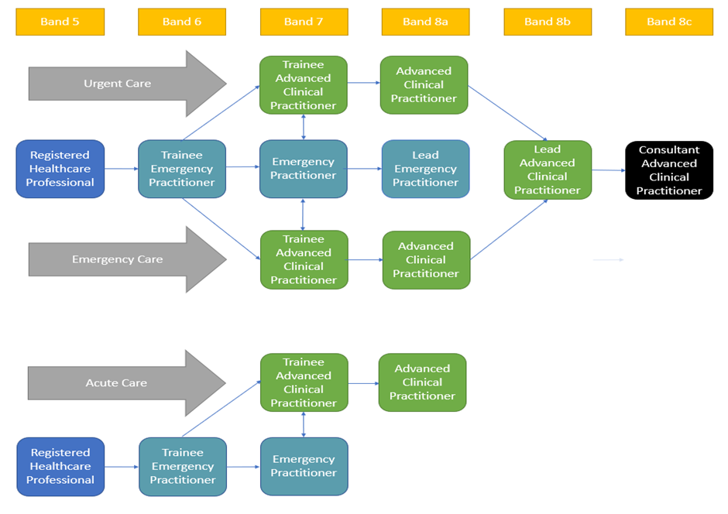
Training and Development
The Trust has dedicated Learning and Education Centres, including libraries at both Peterborough City Hospital and Hinchingbrooke Hospital sites. The Learning Centres provide multiple educational events for both clinical and non-clinical staff.
The Division recognises the needs and benefits of having a strong commitment to the education and continuing professional development (CPD) of its staff. In addition, each department within the Division holds education sessions tailored to the specialty and shares learning via Divisional Governance Meetings, Clinical Business Unit Meetings. Staff also have the opportunity to attend Trustwide knowledge sharing events at the Cautionary Tales Forum. These are hosted by the Trust’s Medical Director and will focus on one or two key cases and are open to all staff.
Audit/Clinical Governance
The Trust places great emphasis on the continuing professional development of all employees and extensive training opportunities are available both internally and externally which the successful candidate would be encouraged to participate. The Trust also sets aside a protected clinical governance/ audit half day every month which provides the opportunity for each specialty to carry out mandatory training and to discuss their own audit projects in which the Department participates and encourages all members of staff to be active.
General Conditions of Employment
Nurses joining the Trust must hold a valid and up to date NMC registration. Nurses are required to maintain their NMC registration throughout their employment with the trust. This involves meeting the NMC’s continuous professional development (CPD) requirements, which include completing regular training and learning activities to enhance their knowledge and skills.
All appointments are subject to satisfactory Occupational Health Clearance being obtained and a satisfactory DBS check.
The appointment is exempt from the provisions of Section 4(2) of the Rehabilitation of Offenders Act 1974 by virtue of the Rehabilitation Act 1974 (Exemptions) Order 1975.
Applicants are not entitled therefore to withhold information about convictions which for other purposes are ‘spent’ under the provision of the Act, and in the event of employing any failure to disclose such convictions could result in dismissal or disciplinary action by Trust. Any information given will be completely confidential and will be considered in relation to an application for positions to which the Order applies.
Subject to the provisions of the Terms and Conditions of Services, the appointee is expected to observe the Trust’s agreed policies and procedures, drawn up in consultation with the profession on clinical matters, and to follow the standing orders and financial instructions of the Trust

Working at our Trust
- Our Values
Our Trust Values highlight the core principles and ideals of our Trust and underpin everything that we do. They establish the kind of people we want to be, the service we hope to provide and how we interact with our stakeholders and community.
The Values were created and selected by members of the public, patients and our staff, and highlight the principles we believe are the most important. They steer the decisions we make and guide the behaviour of our Trust family so we can accomplish our Vision.
We regularly measure ourselves against these Values, at every organisational level, so we can identify how we are living them and where we need to make improvements. The Trust board will monitor and review how the Trust performs against the values regularly, to ensure we provide the best possible patient care.
- Divisional Structure
Following the formation of North West Anglia Foundation Trust in April 2017, our operational functions across our hospitals merged to form five clinical divisions:
- Division of Medicine
- Division of Urgent Care and Emergency Care
- Division of Surgery
- Division of Family and Integrated Support Services
- Division of Maternity, Gynaecology and Breast Services
The clinical divisions are key to our service delivery and they are led by a triumvirate comprising a Divisional Director, Divisional Nursing Director, and Divisional Operations Director.
- Your responsibilities to the Trust, our patients and staff
The Trust aims to provide high standards of patient care and to ensure that our staff are supported in their roles that help us achieve this. As part of your role, you are expected to adhere to Trust policies and procedures which are designed to guide you in your work and ensure that the Trust, and you as an individual, comply with legal requirements. Non-adherence to Trust policies and procedures may be addressed through the Trust’s disciplinary process.
Key policies are outlined below; you are also required to act by policies specific to your job role, which are covered at induction.
Equality and Diversity Policy
No patient or member of staff should receive less favourable treatment on grounds of age, disability, gender reassignment, marriage and civil partnership, pregnancy and maternity, race, religion or belief, sex, or sexual orientation, and should not be placed at a disadvantage which cannot be shown to be justifiable. You have a responsibility to patients and staff to ensure that this is achieved.
Health & Safety
You have a responsibility to consider yourself and anyone else that could be affected by the things you do or don’t do, that you should have while at work. You are responsible for informing your manager of any health and safety concerns you identify by using the trust incident reporting system for any accidents, incidents or near-misses that happen to you or that you are aware of to reduce injuries or loss.
Additionally, if you have management responsibilities you must ensure the implementation of the Trust’s health and safety and risk management policies, procedures, and codes of practice through your directorate or business unit management structure ensuring that communication pathways are clear and explicit at all levels of employment, to maintain the health, safety and welfare of employees or others who may be affected.
Data Protection
You are to always maintain the highest standards of data protection and confidentiality, ensuring that person-identifiable data is held securely (including password protection and encryption) and that data held and entered into Trust systems is correct. You are to observe confidentiality for commercially sensitive data and to promote the highest standards of information governance by the Data Protection Act 1998, Freedom of Information Act 2000 and Trust policies and procedures.
Data Quality
It is your responsibility to ensure that any data collection required is accurate, timely, complete, and stored securely in the appropriate place or system, whether as a paper or an electronic record. This includes data input onto the Trust’s information systems, patient records, staff records and finance records. You are expected to submit data for quality assurance checks as required. You will be expected to undertake training required to assure the quality of data collected and to participate in any relevant audits required as part of the Trust’s and external quality improvement programmes.
Customer Care
You are always required to put the patient first and do your utmost to meet their requests and needs courteously and efficiently. So that you to understand the principles of customer care and the effects on you and the service that you provide, full training will be given.
Values
How our staff live and work according to our values will be through our ‘personal responsibility framework’ - which outlines how staff are expected to behave.
Infection Control
You have a responsibility to comply with Trust policies for personal and patient safety and prevention of healthcare-associated infection (HCAI); this includes a requirement for consistent compliance with hand hygiene, use of personal protective equipment and safe disposal of sharps. You will be asked about adherence to measures for reducing HCAI at the annual appraisal.
Smoking Policy
You are not allowed to smoke in Trust buildings or grounds. Assistance will be provided to assist you to quit smoking through our Occupational Health service.
Confidentiality
Under no circumstances, either during or after the end of your employment may you divulge any unauthorised personal identifiable information relating to the Trust. This also includes but is not limited to, information covering patients, individual staff records, industrial relations, financial affairs, contract terms and prices or business forecasts.
Safeguarding the welfare of children and vulnerable adults
You should be aware of Trust policies and procedures on safeguarding the welfare of children and vulnerable adults., and appreciate the importance of listening to children, young people, and vulnerable adults, particularly when they are expressing concerns about their own or other children’s/vulnerable adult’s welfare.
Mandatory Training
You are required to attend mandatory training as required. if you are unable to attend a required session you should ensure that this is rectified with your line manager's support at the next available opportunity.
Raising issues of Concern
If you have any concerns about practices or processes within the Trust, you should raise this with your line manager. If you do not feel able to raise concerns directly you should access the Trust’s haven procedures for raising issues of concern in confidence.

